“PLAYMATES TOYS, EXCLUSIVE SIMPSONS™ INTERACTIVE FIGURES BY MAIL”

EXCLUSIVE LLEWELLYN SINCLAIR AND
COODER INTERACTIVE FIGURE OFFER

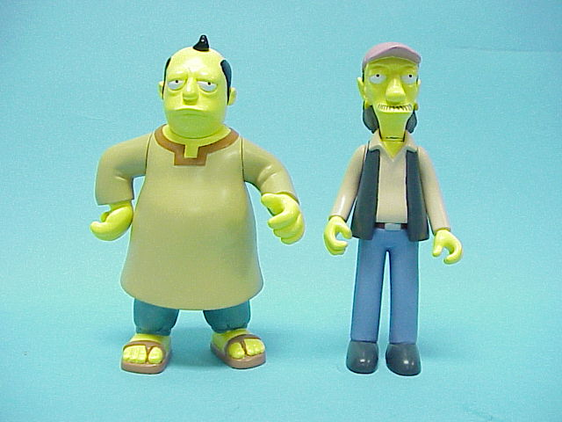

Order Details: To receive the exclusive Llewellyn Sinclair and Cooder Interactive Figures by mail, follow these simple instructions:

Buy: Two (2) or more Playmates Toys’ Simpsons™ “Series 1 thru 9 World of Springfield Interactive Figures”, “Interactive Environments”, “Series 1 and 2 All-Star Voices Interactive Figures”. (Can purchase 2 figures, 2 environments, or 1 of each product category in combination.)
Please Note: Toys R Us Exclusive, Treehouse of Horror Interactive Ironic Punishment Environment is not included in this promotion.

Send: This completed certificate, plus two (2) proof-of-purchase symbols (UPC Codes) from Playmates Toys “Series 1 thru 9 World of Springfield Interactive Figures”, “Interactive Environments”, or “Series 1 and 2 All-Star Voices Interactive Figures” product purchases, an original dated sales receipt, plus $5.00 for shipping and handling, in a check or money order, made payable to Playmates Toys. (Sales receipts dated before 8/15/02 will not be accepted.)

Mail to: Playmates Simpsons Limited Edition Interactive Figure Mail-In Offer
P.O. Box 42903, Offer# 2424
Mesa, AZ 85274-2903

Receive: Exclusive Simpsons™ Llewellyn Sinclair and Cooder Interactive Figures by mail. The
figures will be poly bagged and packaged together in a mail order carton. They will not
be packaged in a blister card or window box.

(Please Print Clearly)
Name:______________________________Age:______________

Address:____________________________Apt.#_____________

City:________________State:__________Zip:_______________

E-Mail Address:_________________________________________

Offer expires 10/31/02. Sales receipts dated before 8/15/02 will not accepted. No duplication or reproduction of UPC/Purchase Seals and sales receipts will be accepted. Group requests will not be accepted. Offer good only in USA. Limit one request per envelope. Void where prohibited, taxed or restricted by law. Playmates Toys, Inc., is not responsible for lost, late, misdirected or illegible mail. Please allow 6-8 weeks for delivery. Good while supplies last. © Playmates Toys, Inc.

The Simpsons™ & © 2002 Twentieth Century Fox Films Corporation. All Rights Reserved. Playmates Toys, Inc. Authorized User.

